**Berkshire Future Land Use Map – Interactive Map**

The purpose of this online interactive future land use map is to allow township property owners to provide input on preferred land uses in the 36/37/71 interchange area. The comments received on this interactive map will be help the township decide on the type of uses to include in the future zoning districts for this area. Note, the Township Trustees want to ensure that **Township Property Owner** comments are reflected in the future land use analysis.  Please ensure that you leave your name and address in the comment of each pin that you drop.  The Township will be reviewing comments with valid township addresses.

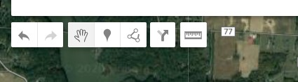Click on “Pin” Icon:

Drop the pin on the area of the map where you want to leave a preferred land use. A comment box will appear.

In the title box, delete the Pont # and type your preferred land use.

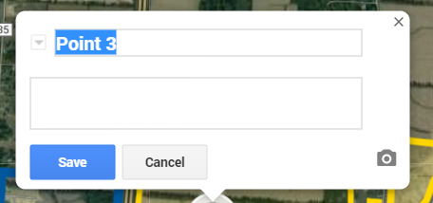

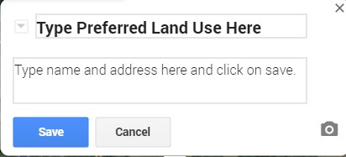In the comment box type your name and address so that the Township Trustees will ensure property owner comments are being reviewed. Click on save. Repeat for any other areas where you would like to comment.

Example:

Possible Preferred Land Uses:

Retail

Restaurants

Office

Residential

Mixed Use (Retail/office on ground floors and residential uses on upper floors)

Industrial

Warehousing

Create your own!